# CHAPTER- 1

Construction Company

INTRODUCTION

An introduction letter is used as a tool for marketing. An introduction letter mainly gives details about a particular company and its services. In short, it is more or less a promotion. Just like any other promotion works, introduction letters should mainly focus on highlighting the most beneficial factors of the respective company.

The essential things that come along with writing an introduction letter are that this henceforth will be the face of your company’s quality, so it should be kept in mind that whatever is written in the letter should be written in formal language and should be very precise

You should keep in mind to mention in brief anything the company has to offer and also portray your company in a good light. This letter will be circulated to companies, so it’s also a matter of reputation for your brand, so you must keep in mind all of this before drafting this letter.

Companies write introduction letters and circulate to other companies or the market to make their firm popular. If you ever need to send an introduction letter for your Company, make sure you study the below-mentioned sample well before sending one.

# Purpose of construction company

Construction projects are often (but wrongly) deemed a success if they stay [on schedule](https://www.strategiaconseil.ca/en/2018/11/19/how-to-reduce-construction-delays-with-time-contingencies/) and under budget.

That comes from the wants or needs of the organization or its stakeholders.

In the construction industry, compliance with the triple objective of cost/time/quality is generally considered to be the criterion for project success (3). From this perspective, on average, budget compliance accounts for 30% of perceived success, schedule compliance for 21%, and quality for 17%.

Factors like safety, stakeholder satisfaction, or environmental impact make up only one third of the criteria for success… even though they often motivate or initiate the project!  /

SMART is a mnemonic acronym that establishes criteria for ideal goals and objectives in a project

. SMART stands for specific, measurable, assignable, realistic and time-related

. This means that a goal must meet these criteria to be considered a SMART goal.

SMART goals help project managers, business managers and any other types of team leaders define clear objectives that should be accomplished by their teams.

Best of all, SMART goals can be used to measure the effectiveness of virtually any project or task.

Within that simple set of criteria is a guide to help teams be more productive, while always keeping goals in mind. Without goals, there is no focus, and without focus the chance of successfully completing a project is slim.

# CHAPTER-2

# EMPATHY MAP:

# 

# BRAINSTORMING :

# 

# CHAPTER-3

**PROFIT AND LOSS ACCOUNT :**

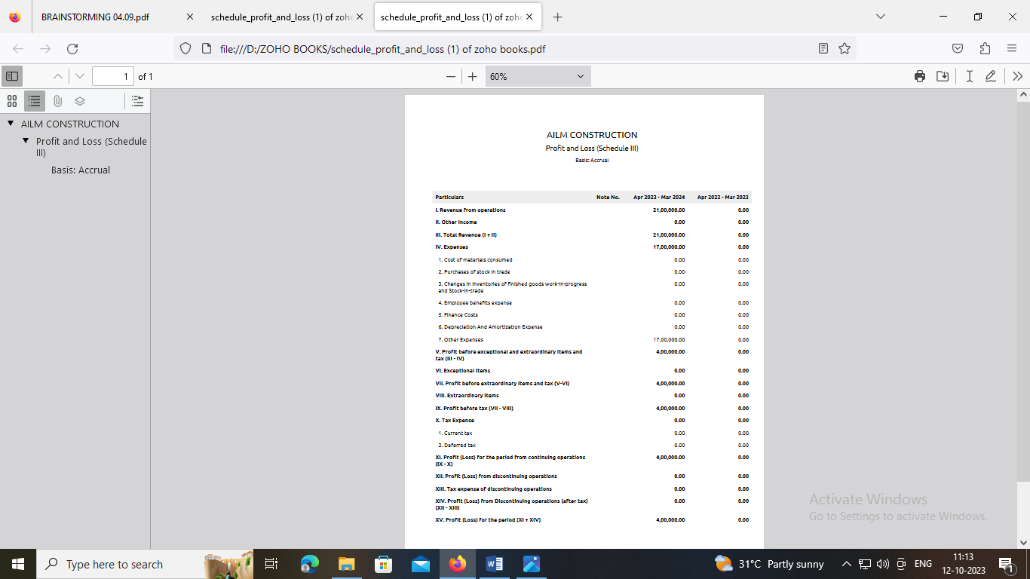

**BALANCE SHEET :**

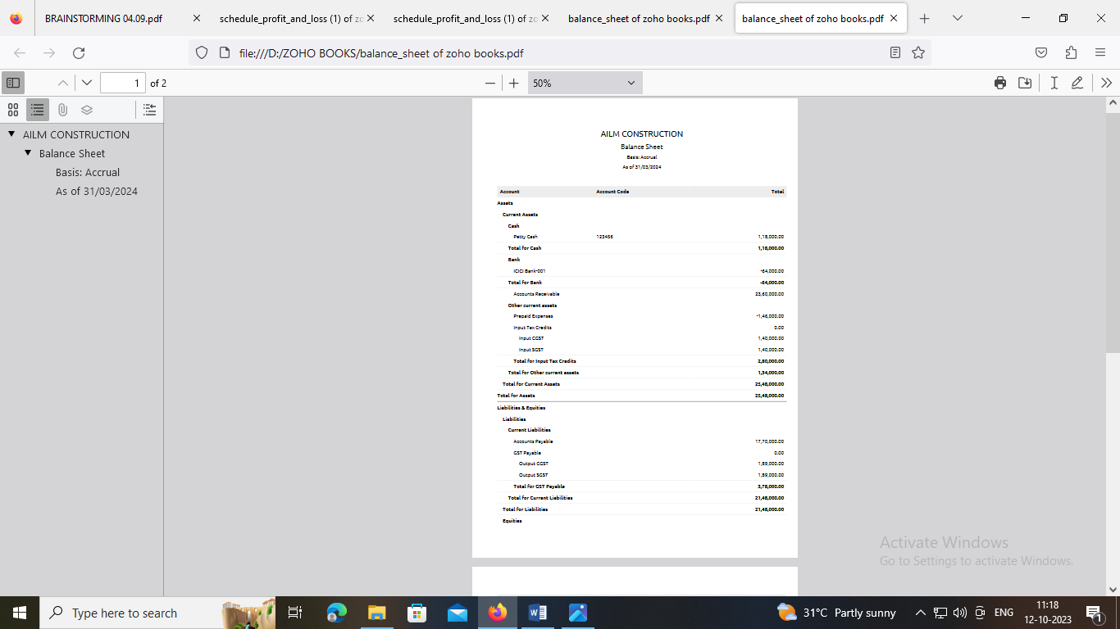

# CHAPTER-4

**ADVANDAGERS OF CONSTRUCTION COMPANY**

* Conducting regular quality control and site inspections
* Running [safety program audits](https://safetyculture.com/checklists/safety-audit-checklists/) on the work premises
* Processing and approving change orders
* Managing costs and work payment schedules
* Arranging necessary permits and insurance
* Responding to Requests for Information (RFIs)
* Coordinating construction teams for on-time completion
* Documenting [change orders](https://safetyculture.com/checklists/change-request/), inspections, [corrective actions](https://safetyculture.com/topics/corrective-action/), communication, and other processes
* Automate [workflows](https://safetyculture.com/iauditor-workflows/) and assign responsibilities with the level of urgency to the appropriate stakeholders
* Monitor the progress of the construction project and gain insights from the field through the [analytics dashboard](https://safetyculture.com/reporting-analytics/)
* Perform safety and quality inspections on the construction site using a mobile device
* Communicate important updates among project stakeholders through the [Heads Up](https://safetyculture.com/heads-up/) feature
* Accomplish [daily logs](https://public-library.safetyculture.io/products/construction-daily-log?amp_dev=a74a1470-d008-49fc-94ce-a756fbd56555&sid=1696921805261), [field reports](https://public-library.safetyculture.io/products/construction-daily-report?amp_dev=a74a1470-d008-49fc-94ce-a756fbd56555&sid=1696921805261), and other records using custom templates from the [Public Library](https://public-library.safetyculture.io/?amp_dev=a74a1470-d008-49fc-94ce-a756fbd56555&sid=1696921805261)

**DISADVANTAGES OF CONSTRUCT ION COMPANT**

One of the main factors that affect construction profitability is the [**complexity of the project**](https://www.linkedin.com/advice/1/how-can-you-simplify-complex-construction-projects?trk=article-ssr-frontend-x-article_little-text-block).

Complexity can refer to the size, scope, design, technology, location, and duration of the project, as well as the number and diversity of stakeholders involved.

Complex projects tend to have higher costs, longer schedules, more uncertainties, and more risks, which can reduce the profit margin and increase the likelihood of disputes and claims.

To deal with project complexity, you need to have a clear understanding of the project requirements, scope, and objectives, and use appropriate methods and tools to plan, monitor, and control the project activities and resources.

Agreed. It all starts from the quality of information, the timescales, environment considerations, resources and finance.

Next having a good team to deliver the project along with trusted partners and supply chain will all help.

Cheapest price and crazy time periods poor information are the bain of construction profitability (to mention just a few).

Having suitably skilled people trained on new tools and tech will help too.

Having people who can actually build the thing that they are managing is a big plus.

# CHAPTER-5

**APPLICATION OF CONSTRUCTION COMPANY**

You probably know that cover letters complement resumes and that recruiters just love asking for them. But why are cover letters important?

Well, because they are your chance of telling a story.

And let’s face it – listing different skills and achievements on your resume is essential. But connecting the dots in your cover letter and explaining what’s helped you gain expertise will make you stand out.

Read our proven Construction Worker cover letter tips and examples below.

Let’s begin by discussing the difference between a cover letter and a resume. The resume is the place where you should list all your hard skills, achievements, and talents.

The cover letter, on the other hand, is your chance to share more about yourself and show who you are.

But what’s the way to grab the reader’s attention? How can you make the hiring manager want to meet you and learn more about you?

How do I write an application letter for a construction company?

**Tips to write a memorable construction worker cover letter**

1. Choose the right salutation and write a strong introduction.
2. Link your construction worker soft and hard skills to your achievements. ..
3. Prove how your skills can help the company grow. ...
4. End on a positive note.

# CHAPTER-6

**CONCLUSION OF CONSTRUCION COMPANY :**

As the study progressed it became apparent to the committee that a number of important factors, realities, and issues have major impacts on Reclamation’s ability to respond quickly and effectively to the many diverse pressures and rapid changes occurring today.

Equally important are the capabilities that are needed within Reclamation to deal effectively with the challenges posed by these impacts.

The factors affecting the management of construction and infrastructure and the capabilities that will be needed to respond to these impacts are identified in the following sections.

The findings and recommendations are based on these factors and the detailed discussions in the preceding chapters.

How do you conclude a construction report?

**.**

1. Step 1: Review the project scope and objectives. ...
2. Step 2: Evaluate the project performance and outcomes. ...
3. Step 3: Document the project deliverables and closure. ...
4. Step 4: Analyze the project risks and issues.

When [creating a comprehensive business report](https://databox.com/business-report) for your company, most of your time and energy will go into writing the main section of your report.

Once you come to the conclusion, you will probably be exhausted and you may feel the urge to just ‘wrap it up’ as soon as possible.

This can be a costly mistake.

Your conclusion carries the same importance as all the other sections of the report since it leaves the final impression on the reader.

# CHAPTER-7

**FUTURE SCOPE OF CONSTRUCTION COMPANY**

### The Construction industry in India consists of the Real estate as well as the Urban development segment.

### The Real estate segment covers residential, office, retail, hotels and leisure parks, among others.

### While Urban development segment broadly consists of sub-s The construction Industry in India is expected to reach $1.4 Tn by 2025.

* **Cities Driving Growth**
* - Urban population to contribute 75% of GDP (63% present), and 68 cities will have a population of more than 1 Mn.
* The construction industry market in India works across 250 sub-sectors with linkages across sectors.
* **Residential**-
* By 2030, more than 40% of the population is expected to live in urban India (33% today), creating a demand for 25 Mn additional mid-end and affordable units.
* Under NIP, India has an investment budget of $1.4 Tn on infrastructure - 24% on renewable energy, 18% on roads & highways, 17% on urban infrastructure, and 12% on railways.
* **Schemes such as the revolutionary Smart City Mission**
* (target 100 cities) are expected to improve quality of life through modernized/ technology driven urban planning.
* 54 global innovative construction technologies identified under a Technology Sub-Mission of PMAY-U to start a new era in Indian construction technology sector.
* Over 3,500 cities have certified as ODF+ and 1,191 cities as ODF++ under SBM-U.
* 35 Multimodal Logistics Parks (MMLPs) to be developed at a total capital cost of $ 6.1 Bn, will cater to 50% of the freight movement.

**Union Budget 2023 Highlights:**

* INR 10 Lakh Crore: 33% Increase in capital Investment Outlay

egments such as Water supply, Sanitation, Urban transport, Schools, and Healthcare.